**PHP/My SQL E-Project**



**Submitted To**

[eprojects@aglsm.com](mailto:eprojects@aglsm.com)

**Project Instructor**

Miss Tehreem Mushtaq

**Curriculum Code**

OV-6740

**Group Members**

*Neha Mehmood*

*Rumaisa Amir*

*Habiba Nasir*

*Kaif Ali*



# 

**Table of Contents**

*ACKNOWLEGDMENT* 3

*PROJECT CERTIFICATION* 4

*INTRODUCTION TO CELLINFO* 5

*REQUIRMENT SPECIFICATION* 5

*(A) HARDWARE REQUIRMENT* 5

*(B) SOFTWARE REQUIRMENT* 5

*PROJECT DURATION* 6

*TASK SHEET* 7

*SNAPSHOT* 8

# ACKNOWLEDGEMENT

***W***

*e are thankful to Almighty, ALLAH that by His grace we have been successful. we presenting on* ***PHP/MySQL*** *in your hands. We have tried our best to take all relevant important topics in consideration so that this project may become comprehensive.*

*This is our* ***Third Semester E****-****project****. We have tried our best & struggled for a better outlook to come. This project has been developed in* ***PHP/MySQL.*** *We choose to make Webpage for* ***Lawyer Website*** *as a project. We find easy to do coding in* ***PHP/MySQL***

*We earnestly hope that this project will provide all the necessarily information required for the user to fulfill their inspiration. However suggestions for improvement of the project will be thankful received & acknowledge.*

**

**THANKING YOU.**

# Project Certification

*This is to certify that,*

*Neha Mehmood, Rumaisa Amir, Kaif Ali, Habiba Nasir as successfully Designed & Developed* **"Lawyers Website*"***



*Date of Issue:*

***11-June-2022***

*Authorized Signature:* ***Miss Tehreem Mushtaq***

**Introduction**

**INTRODUCTION**

The thirst for learning, upgrading technical skills and applying the concepts in real life environment at a fast pace is what the industry demands from IT professionals today. However busy work schedules, far-flung locations, unavailability of convenient time-slots pose as major barriers when it comes to applying the concepts into realism. And hence the need to look out for alternative means of implementation in the form of laddered approach.

The above truly pose as constraints especially for our students too! With their busy schedules, it is indeed difficult for our students to keep up with the genuine and constant need for integrated application which can be seen live especially so in the field of IT education where technology can change on the spur of a moment. *Well, technology does come to our rescue at such times!!*

Keeping the above in mind and in tune with our constant endeavour to use Technology in our training model, we at Aptech have thought of revolutionizing the way our students learn and implement the concepts using tools themselves by providing a *live and synchronous eProject learning environment!*

**So what is this eProject?**

eProject is a step by step learning environment that closely simulates the classroom and Lab based learning environment into actual implementation. It is a project implementation at your fingertips!! An electronic, live juncture on the machine that allows you to

* Practice step by step i.e. laddered approach.
* Build a larger more robust application.
* Usage of certain utilities in applications designed by user.
* Single program to unified code leading to a complete application.
* Learn implementation of concepts in a phased manner.
* Enhance skills and add value.
* Work on real life projects.
* Give a real life scenario and help to create applications more complicated and useful.
* Mentoring through email support.

The students at the centre are expected to complete this eProject and send complete documentation with source code to eProjects Team

Looking forward to a positive response from your end!!

**Hardware/ Software Requirements**

**Hardware**

* A minimum computer system that will help you access all the tools in the courses is a Pentium 166 or better
* 128 Megabytes of RAM or better

**Operating System**

* LINUX / Windows 2000 Server (or higher if possible)

**Software**

* PHP
* MySQL
* PERL
* Apache

# 

# Task Sheet

|  |  |  |  |  |  |
| --- | --- | --- | --- | --- | --- |
| *No.* | TASK | *Actual Start Date* | *Actual Days* | *Team Mate Name* | *Status* |
| 1. | Analysis | 11-June-2022 | 2 | Rumaisa Amir, Neha Mehmood, Kaif Ali Zaidi, Habiba Nasir |  |
| 2. | Design | 13-June-2022 | 9 | Neha Mehmood, Habiba Nasir |  |
| 3. | Development | 17-June-2022 | 15 | Rumaisa Amir, Neha Mehmood, Kaif Ali Zaidi, Habiba Nasir |  |
| 4. | Testing | 05-July -2022 | 3 | Neha Mehmood , Kaif Ali Zaidi |  |
| 5. | Documentation | 12-July-2022 | 1 | Neha Mehmood, Rumaisa Amir, Habiba Nasir |  |
| 6. | Finalization | 13-July-2022 | 4 | Rumaisa Amir, Neha Mehmood, Kaif Ali Zaidi, Habiba Nasir |  |

# Snap Shots

**HOME**

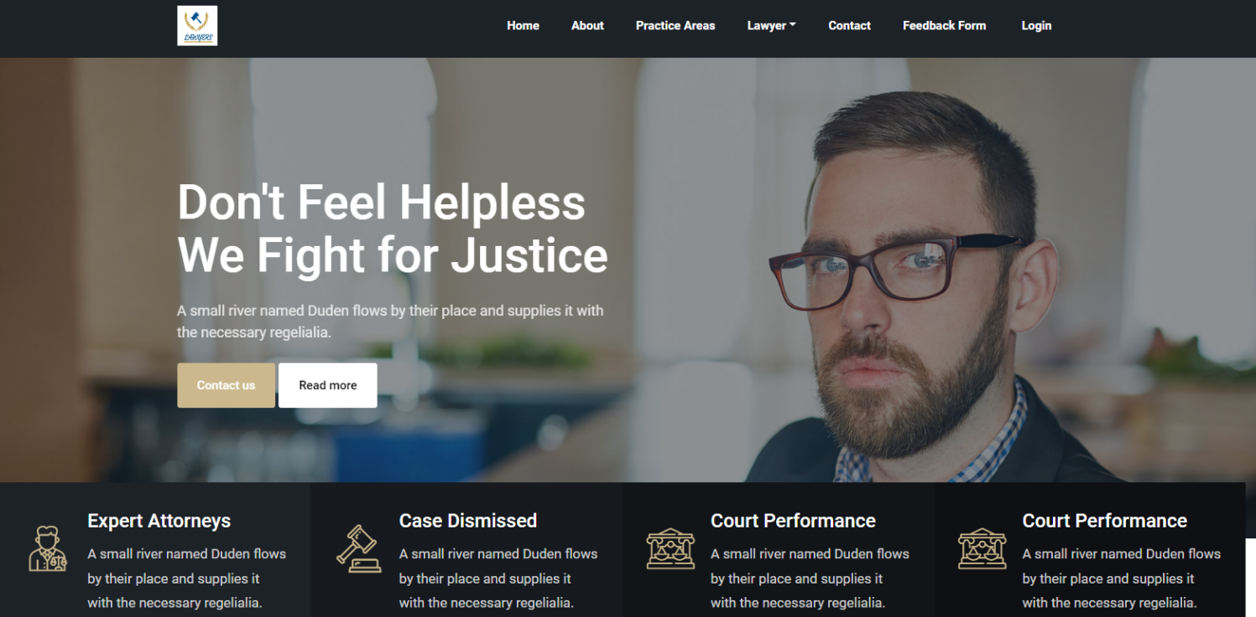 That’s Our Home Page With A Workable Navbar, Containing Different Lawyers With Their Information

**FOOTER**

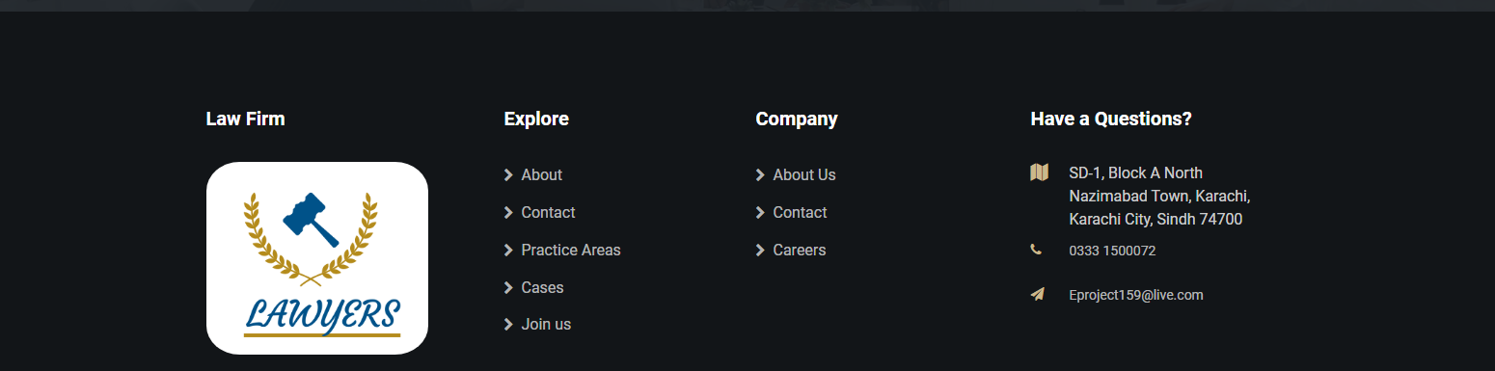

Footer Show Our Perfect Navigation Of The Page

**LAWYERS**



These are our lawyers.

**Booking details**

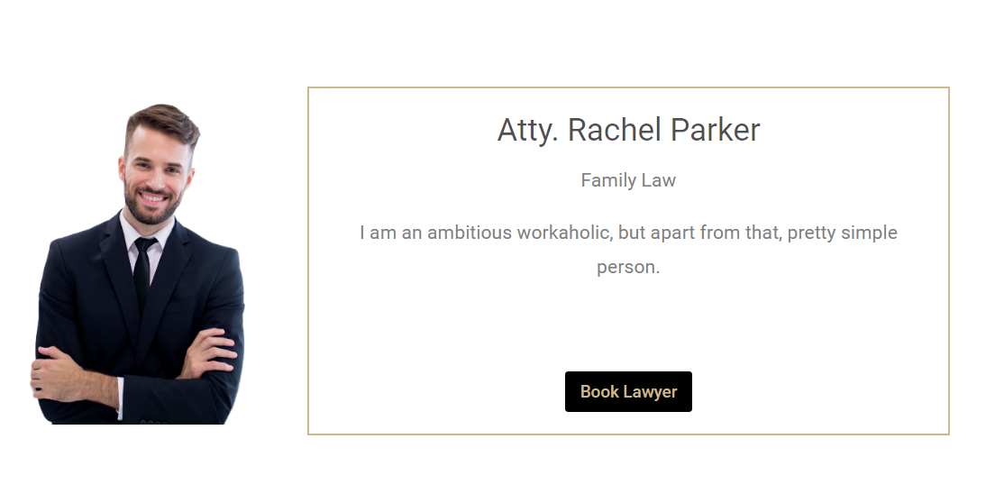

From this page you can book your appointment.

**CONTACT US**

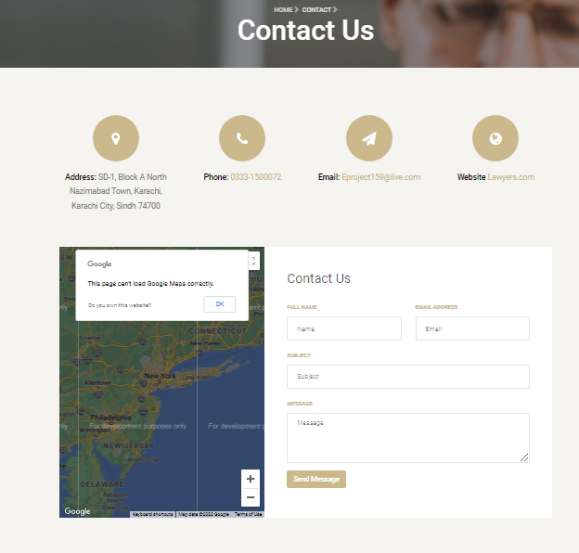 From this page and giving all your information that are required you can contact us**.**

**ABOUT US**

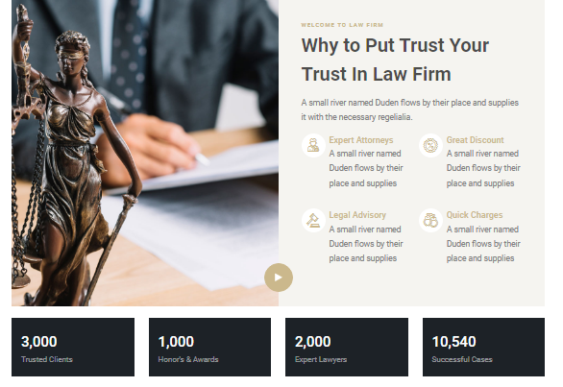

That’s A Little Information About Our Project

**ADMIN PANEL**

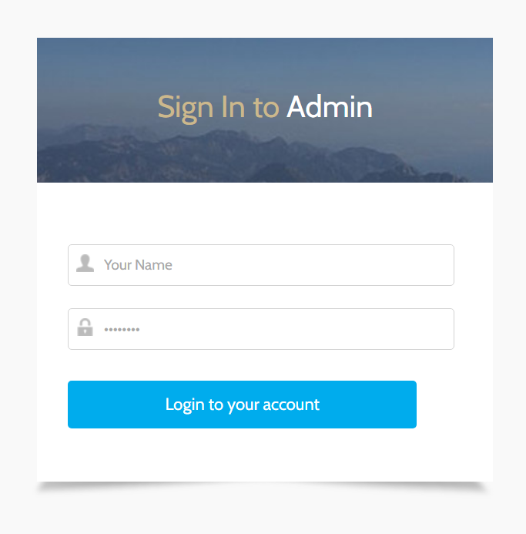

That’s Our Admin Page, You Can Add Username Or Password To Login The Page For Admin.

**Lawyer PANEL**

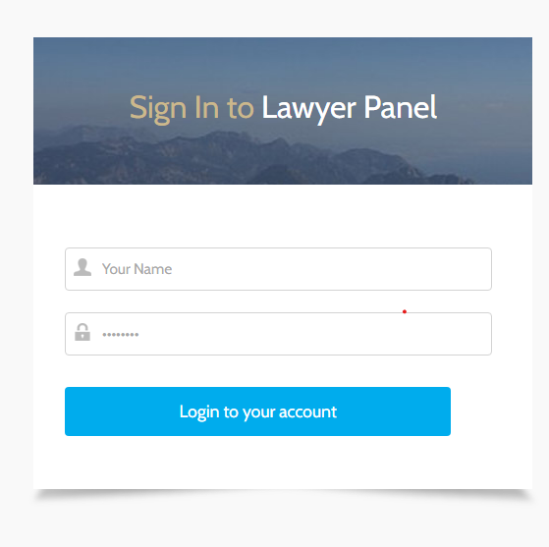

**that’s our Lawyer panel.**